**LAB # 06**



**CSE301L-Signal and System**

Submitted by: **Maaz Habib**

Registration No: **20PWCSE1952**

Class Section: **C**

“On my honor, as student of University of Engineering and Technology, I have neither given nor received unauthorized assistance on this academic work.”

Student Signature: ______________

Submitted to:

**Engr Durr-e-Nayab**

June 5, 2022

**Department of Computer Systems Engineering**

**University of Engineering and Technology, Peshawar**

**OBJECTIVES OF THE LAB**

‐‐‐‐‐‐‐‐‐‐‐‐‐‐‐‐‐‐‐‐‐‐‐‐‐‐‐‐‐‐‐‐‐‐‐‐‐‐‐‐‐‐‐‐‐‐‐‐‐‐‐‐‐‐‐‐‐‐‐‐‐‐‐‐‐‐‐‐‐‐‐‐‐‐‐‐

* In this lab, we will cover the following topics:
* *Generating Sinusoids*
* *Addition of Sinusoids with Variation in Parameters and their Plots*
* *Linear Phase Shift Concept When Dealing With Sum of Sinusoids*

‐‐‐‐‐‐‐‐‐‐‐‐‐‐‐‐‐‐‐‐‐‐‐‐‐‐‐‐‐‐‐‐‐‐‐‐‐‐‐‐‐‐‐‐‐‐‐‐‐‐‐‐‐‐‐‐‐‐‐‐‐‐‐‐‐‐‐‐‐‐‐‐‐‐‐‐

**-------------------------TASK 01--------------------------**

* Generate the 1x10 row vector *v* whose *i*‐th component is cos (iπ/4).

**Source code:**

function[Y,x]=Task01

disp('*******Task 01********');

disp('A Vector of size 1x10 having each ith element=cose(i*pi/4)');

i=1:10;

Y=cos(i*pi/4);

plot(i,Y,'r','Linewidth',2);

xlabel('X-axis');

ylabel('Y-axis');

%2nd Method

for i=1:10

x(i)=cos(i*pi/4);

%if we write x=cos(i*pi/4) then it will not give correct result.

end

**OUTPUT:**

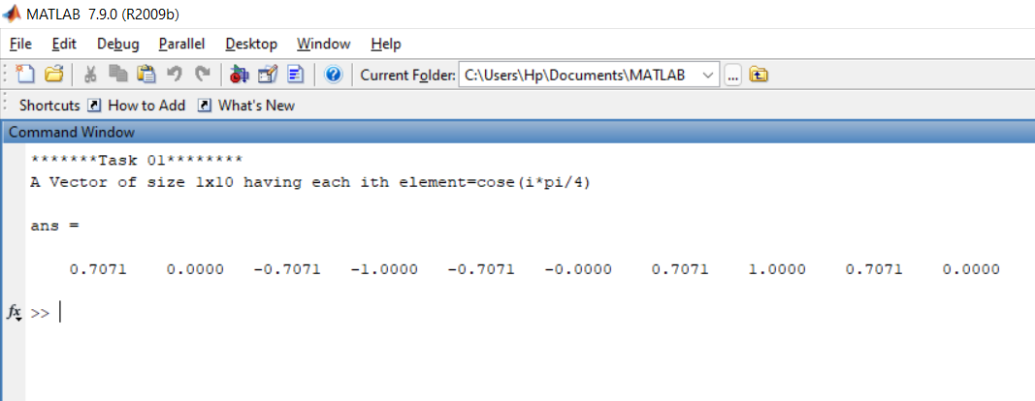

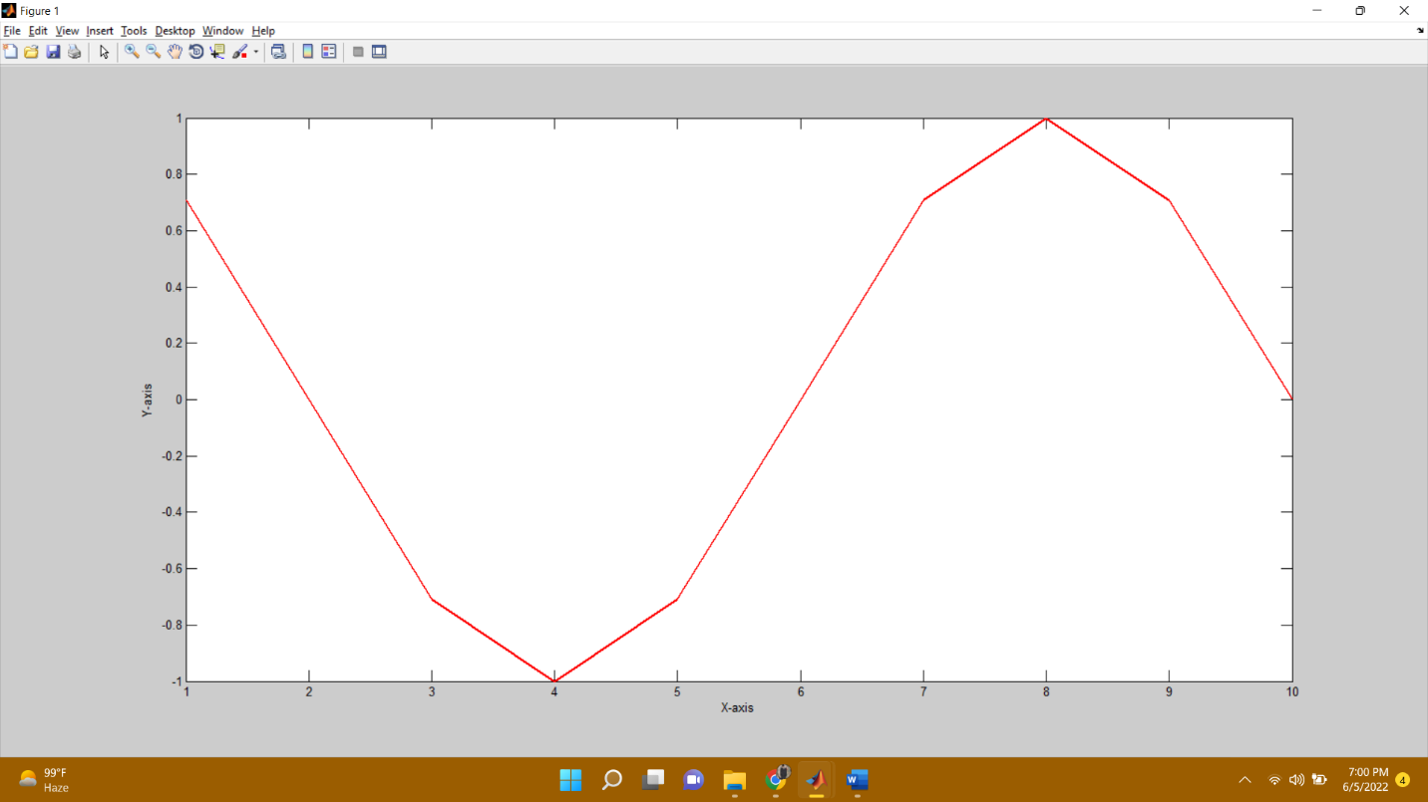

**-------------------------TASK 02--------------------------**

* Write matlab code that draw graphs of sin (nπx) on the interval ‐1≤x≤1 for n = 1, 2, 3, …, 8. (Hint: Use for loop)

**Source code:**

clc

clear all

close all

disp('******Task 02******');

x=-1:0.006:1;

A=3;

for n=1:8;

y=sin(n*pi*x);%here in each iteration y is a vector x no of values.

%if we write like y(i)=sin(n*pi*x) then y is an single element in each

%loop iteration. and it will give error here b/c in each iteration x is

%not a single value but it is a set of value -1:0.006:1

%so the error will be like size of y and x is not same.

subplot(8,1,n)

plot(x,y,'linewidth',2);

%we can also directly write here sin(n*pi*x)instead of y.

grid;

ylabel(n);

xlabel(n);

axis([x(1) x(end) -A A])

end

**Output:**

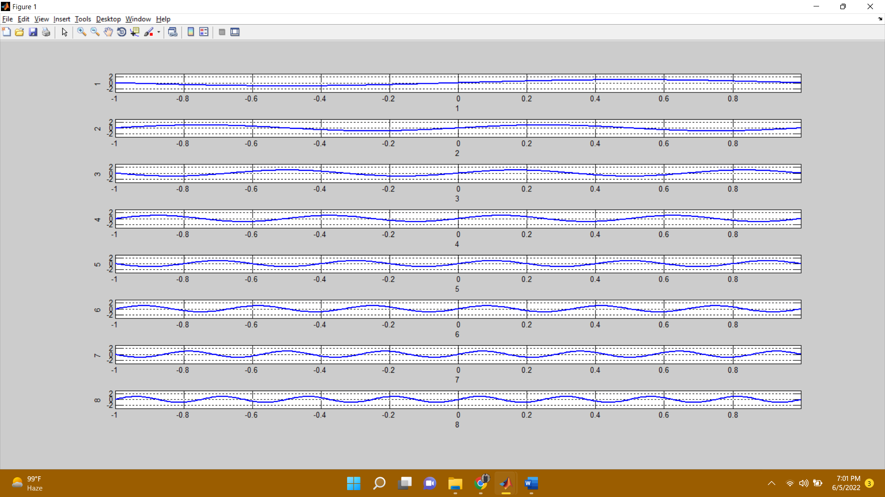

**-------------------------TASK 03--------------------------**

* Given the signal exp(‐x)sin(8x) for 0≤x≤2π, plot its continuous‐time and discrete‐time representations. Use subplot and label properly.

**Source code:**

clc;

clear all;

close all;

disp('*******Task 03*********');

x=0:2*pi;

Y=exp(-x).*sin(8*x);

subplot(2,1,1);

plot(x,Y,'r','Linewidth',2);

xlabel('X-axis');

ylabel('Y-axis');

title('Continues-Time Signal');

subplot(2,1,2);

stem(x,Y,'r','filled');

xlabel('X-axis');

ylabel('Y-axis');

title('Discrete-Time Signal');

**Output:**

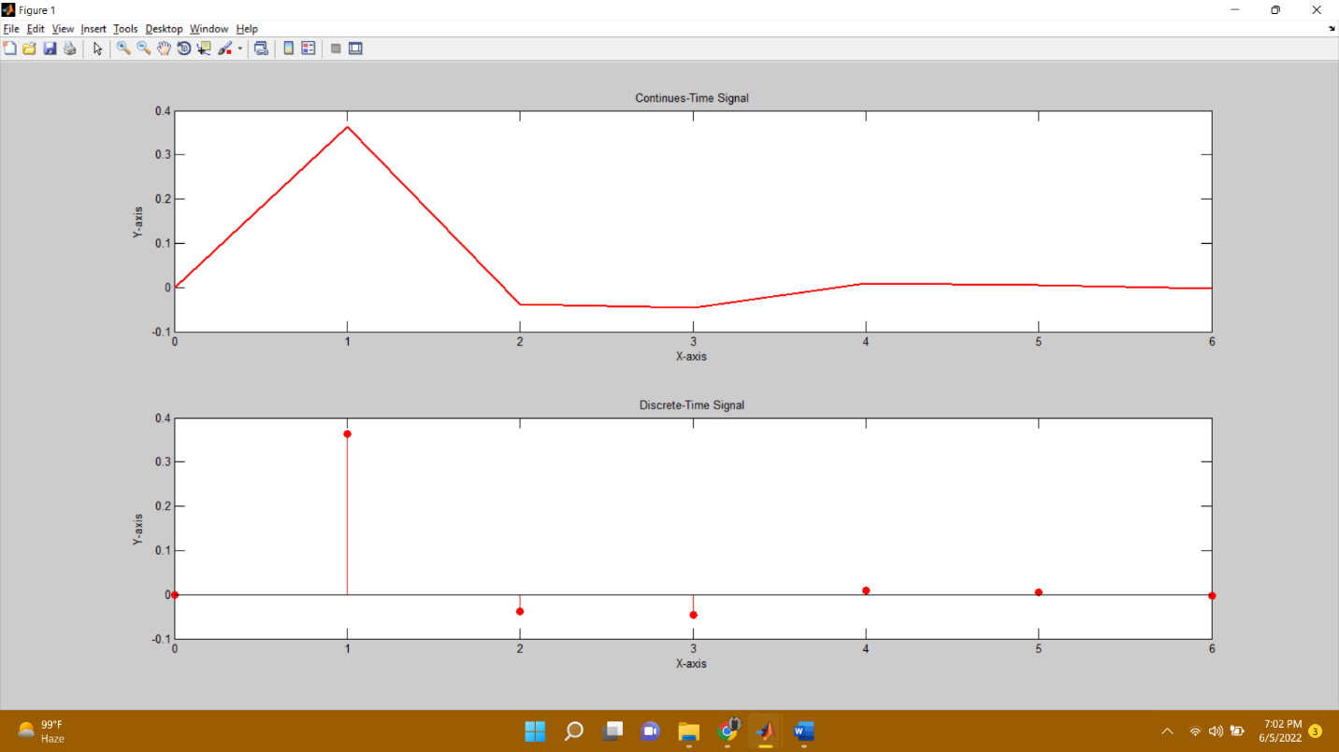

**-------------------------TASK 04--------------------------**

* Modify the example given in topic 6.2 to generate a sine wave with phase shift of +pi/2. Then plot a cosine wave of same frequency, amplitude, and phase shift of 0 in another subplot. Compare both the signals and determine the relationship between the two.

**Source Code:**

clc

clear all

close all

disp('*******Task 04*********');

M=10; %samples/sec

t=-3:1/M:3;

A=2;

f=1;

x=A * sin(2*pi*f*t + pi/2);

y=A * cos(2*pi*f*t + 0);

subplot(2,1,1)

plot(t,x,'r','linewidth', 2)

title('Continues-Time Sine Wave with A=2,f=1,phase=pi/2)')

xlabel('Time Index')

ylabel('Signal Amplitude')

axis([t(1) t(end) -A A])

grid

subplot(2,1,2)

plot(t,x,'r','Linewidth',2)

title('Continues-Time Cosine Wave with A=2,f=1,phase=0)')

xlabel('Time Index')

ylabel('Signal Amplitude')

axis([t(1) t(end) -A A])

grid

**Output:**

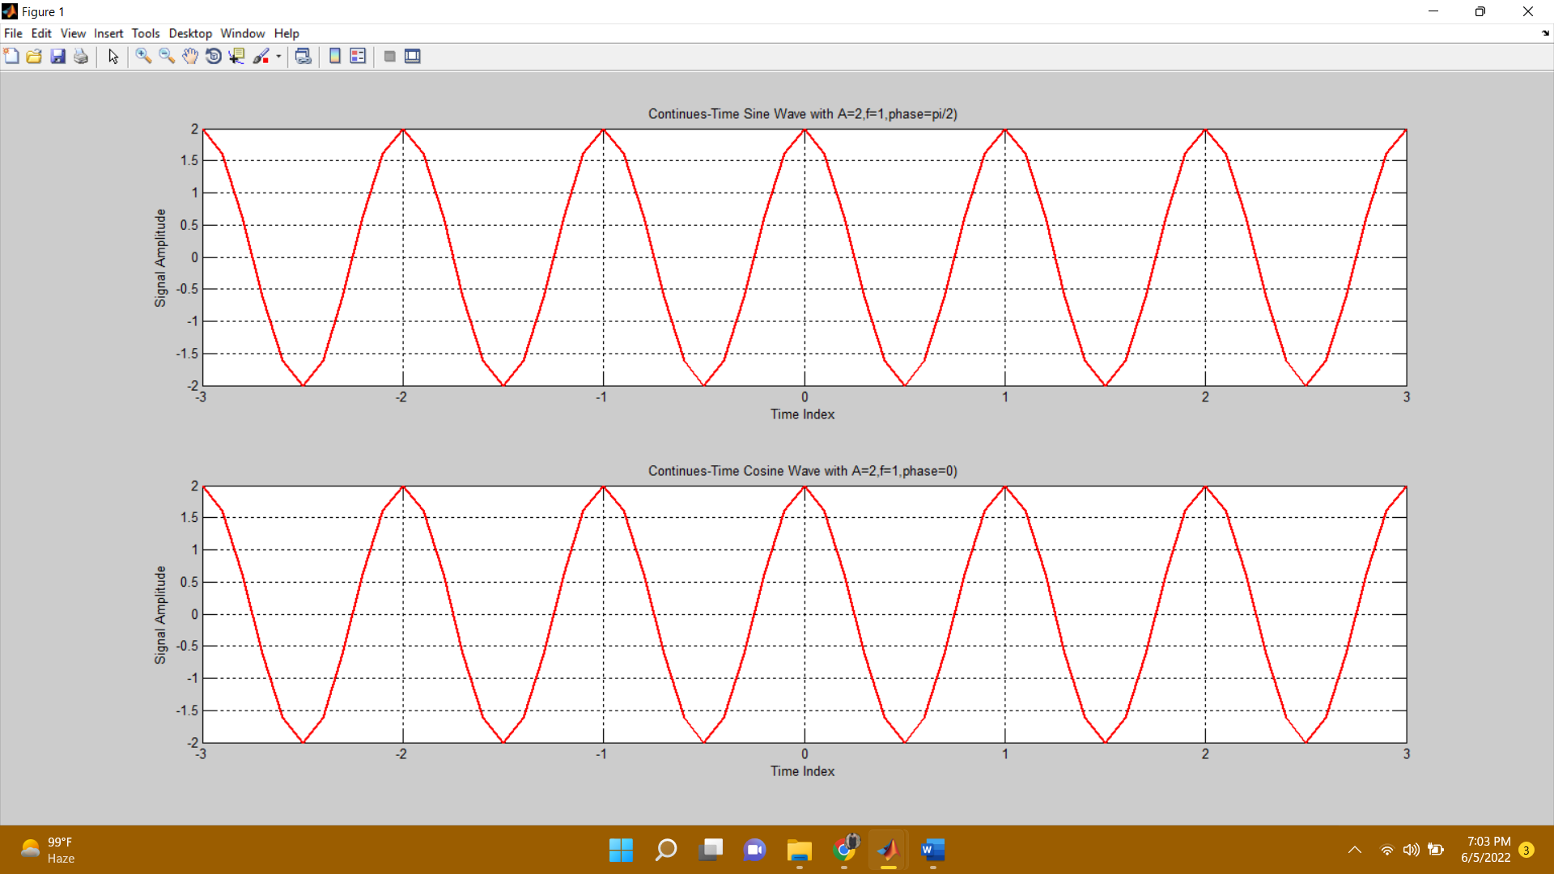

**-------------------------TASK 05--------------------------**

* Write a program to generate a continuous‐time sine wave of frequency 3 Hz, positive phase shift of pi/2, and amplitude of 5. Also generate a continuous‐time cosine wave of frequency 3 Hz, amplitude of 5, and phase shift of 0. Plot the two signals on separate subplots and properly label them. Determine the relationship between the two signals.

**Source code:**

clc

clear all

close all

disp('*******Task 05*********');

M=100; %samples/sec

t=-3:1/M:3;

A=5;

f=3;

x=A * sin(2*pi*f*t + pi/2);

y=A * cos(2*pi*f*t + 0);

subplot(2,1,1)

plot(t,x,'r','linewidth', 2)

title('Continues-Time Sine Wave with A=5,f=3,phase=pi/2)')

xlabel('Time Index')

ylabel('Signal Amplitude')

axis([t(1) t(end) -A A])

grid

subplot(2,1,2)

plot(t,x,'r','Linewidth',2)

title('Continues-Time Cosine Wave with A=5,f=3,phase=0)')

xlabel('Time Index')

ylabel('Signal Amplitude')

axis([t(1) t(end) -A A])

grid

**Output:**

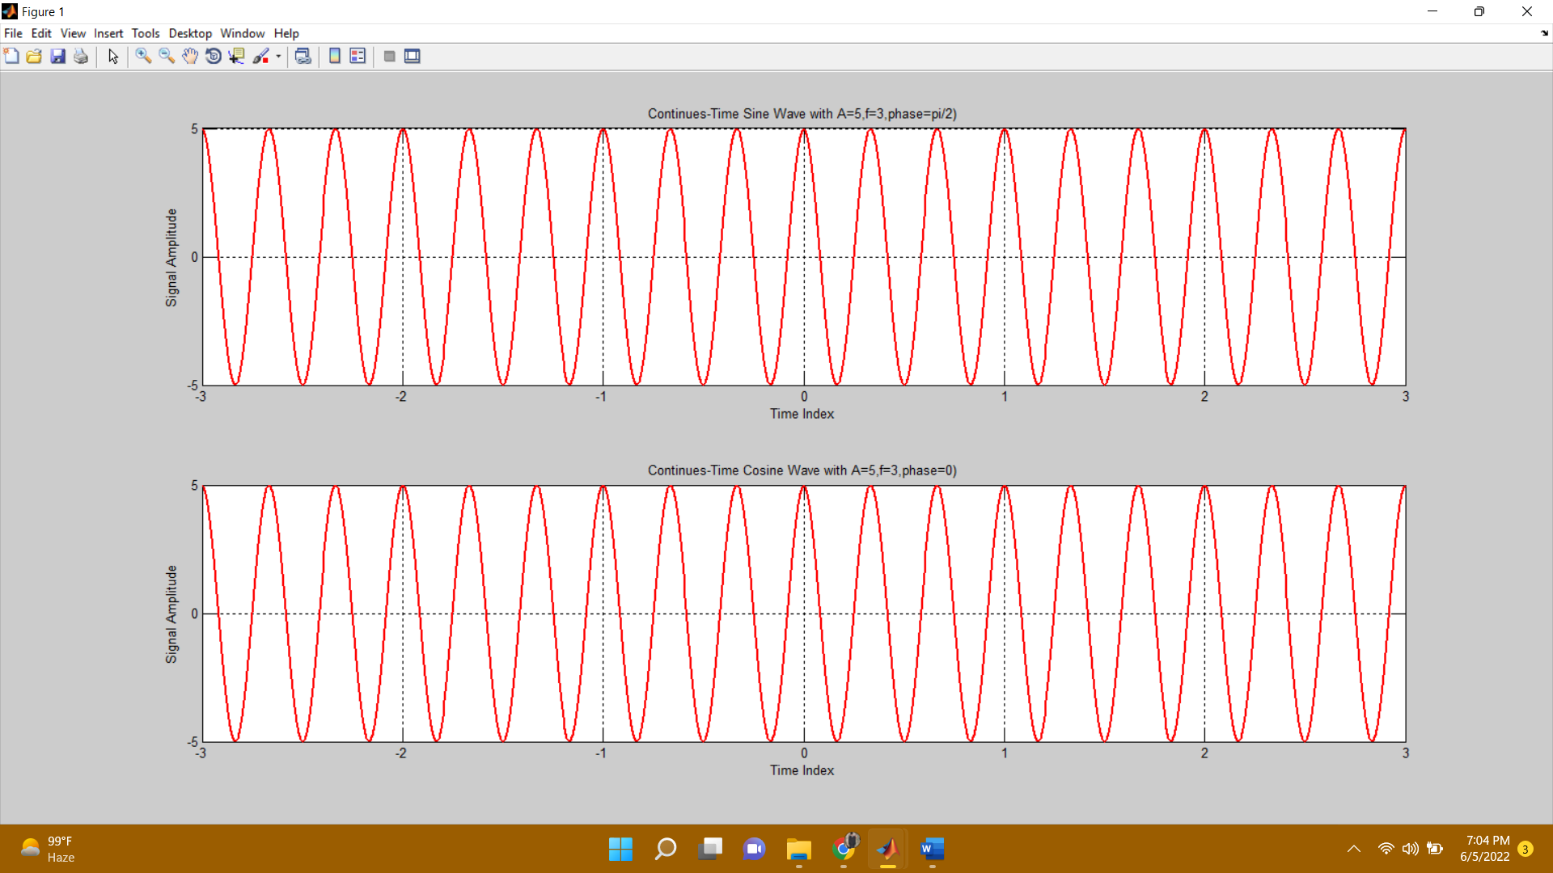

**-------------------------TASK 06--------------------------**

* Write a general program that takes ‘n’ sinusoids from user of same frequency, amplitude, and phase. Plot the individual sinusoids & the resultant using subplot function on same figure. Do perform proper labeling. Note: Take the amplitude, frequency, and phase given in example of case 1. Run the code for different values of n and state the result on paper.

**Source code:**

clc

clear all

close all

disp('*******Task 06*********');

t=-2:0.01:2;

n=input('please enter the no of sinusiods: ');

f=input('please enter the value of frequency: ');

A=input('please enter the amplitude of signal: ');

p=input('please enter the phase angle: ');

Resultent=0;

for i=1:n

y=A * cos(2*pi*f*t + p);

subplot(n+1,1,i)%in subplot we increase size of n for displaying Resultent plot.

plot(t,y,'r','linewidth', 2);

title('Continues-Time Sinusiod with same frequency,Amplitude,phase');

xlabel('Time Index');

ylabel('Signal Amplitude')

Resultent=Resultent+y; %all vectors y are added element by element.

grid on

end

disp('Resultent Vector is: ');

disp(Resultent);

subplot(n+1,1,n+1)

plot(t,Resultent,'b','Linewidth',2);

title('Resultent Signal )');

xlabel('Time Index');

ylabel('Signal Amplitude');

grid on

**Output:**

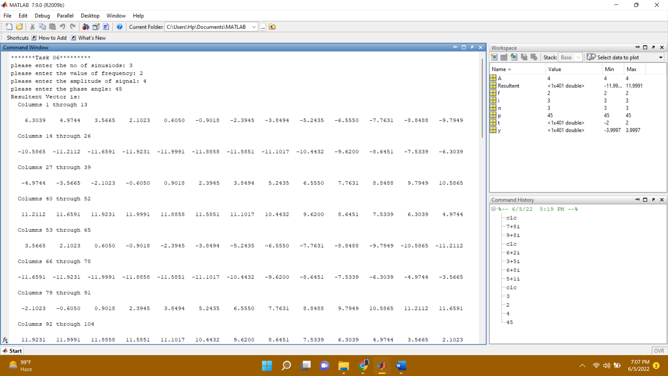

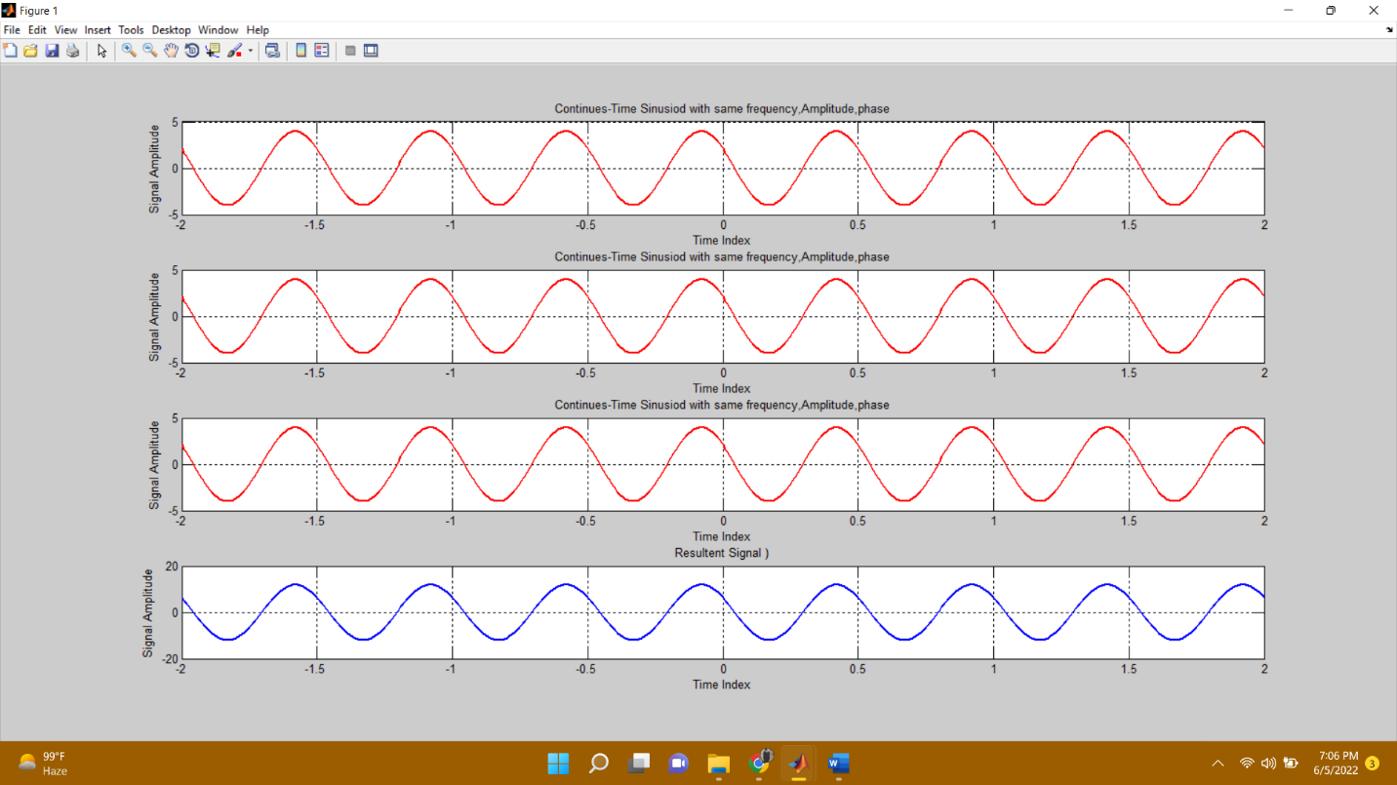

**-------------------------TASK 07--------------------------**

* Write a general program that takes ‘n’ sinusoids from user of same frequency and phase with varying amplitudes. Take amplitude from user on run time. Plot the individual sinusoids & the resultant using subplot function on same figure. Do perform proper labeling. Note: Take the amplitude and frequency given in example of case 2. Run the code for different values of n and state the result on paper.

**Source code:**

clc

clear all

close all

disp('*******Task 07*********');

t=-2:0.01:2;

n=input('please enter the no of sinusiods: ');

f=input('please enter the value of frequency: ');

p=input('please enter the phase angle: ');

Resultent=0;

for i=1:n

A=input('please enter the amplitude of signal: ');

y=A * cos(2*pi*f*t + p);

subplot(n+1,1,i)%in subplot we increase size of n for displaying Resultent plot.

plot(t,y,'r','linewidth', 2)

title('Continues-Time Sinusiod with same frequency,phase but different Amplitude');

xlabel('Time Index');

ylabel('Signal Amplitude');

Resultent=Resultent+y; %all vectors y are added element by element.

grid on

end

disp('Resultent Vector is: ');

disp(Resultent);

subplot(n+1,1,n+1)

plot(t,Resultent,'b','Linewidth',2);

title('Resultent Signal )');

xlabel('Time Index');

ylabel('Signal Amplitude');

grid on

**Output:**

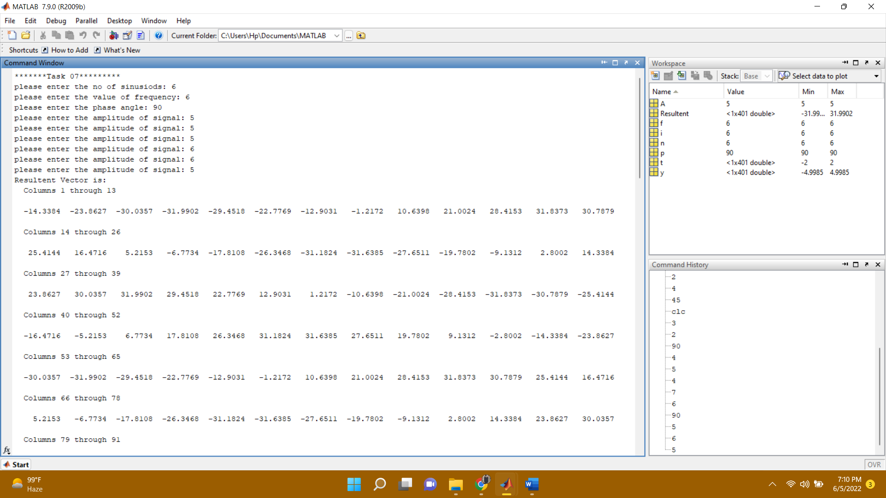

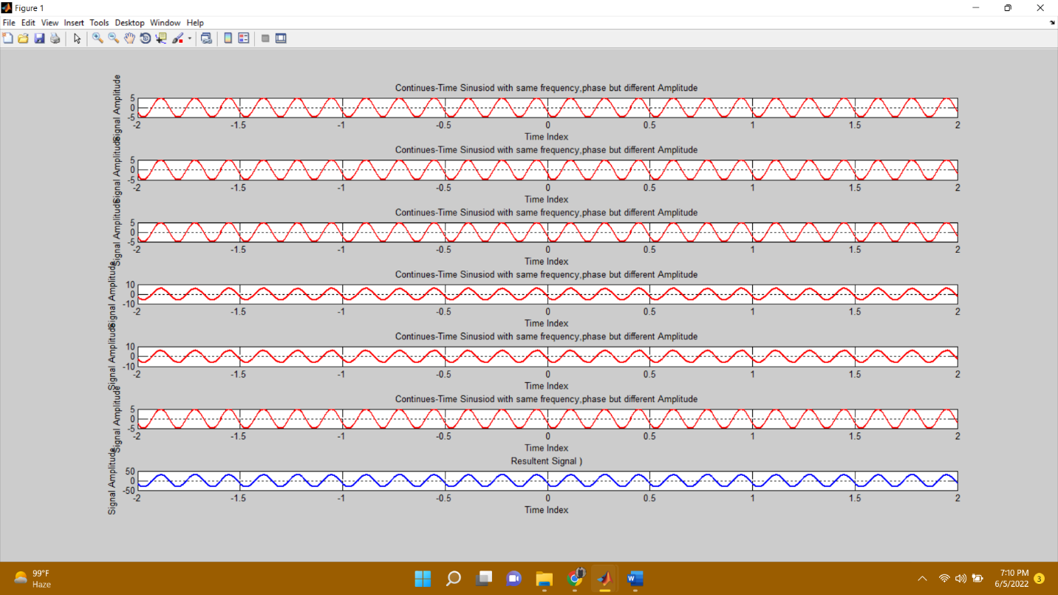

**-------------------------TASK 08--------------------------**

* Write a general program that takes ‘n’ sinusoids from user of same amplitude and phase with varying frequencies. Take each frequency from user on run time. Plot the individual sinusoids & the resultant using subplot function on same figure. Do perform proper labeling. Note: Take the amplitude and phase given in example of case 3. Run the code for different values of n and state the result on paper.

**Source code:**

clc

clear all

close all

disp('*******Task 08*********');

t=-2:0.01:2;

n=input('please enter the no of sinusiods: ');

p=input('please enter the phase angle: ');

A=input('please enter the amplitude of signal: ');

Resultent=0;

for i=1:n

f=input('please enter the value of frequency: ');

y=A * cos(2*pi*f*t + p);

subplot(n+1,1,i)%in subplot we increase size of n for displaying Resultent plot.

plot(t,y,'r','linewidth', 2)

title('Continues-Time Sinusiod with same Amplitude,phase but different frequency');

xlabel('Time Index');

ylabel('Signal Amplitude');

Resultent=Resultent+y; %all vectors y are added element by element.

grid on

end

disp('Resultent Vector is: ');

disp(Resultent);

subplot(n+1,1,n+1)

plot(t,Resultent,'b','Linewidth',2);

title('Resultent Signal )');

xlabel('Time Index');

ylabel('Signal Amplitude');

grid on

**Output:**

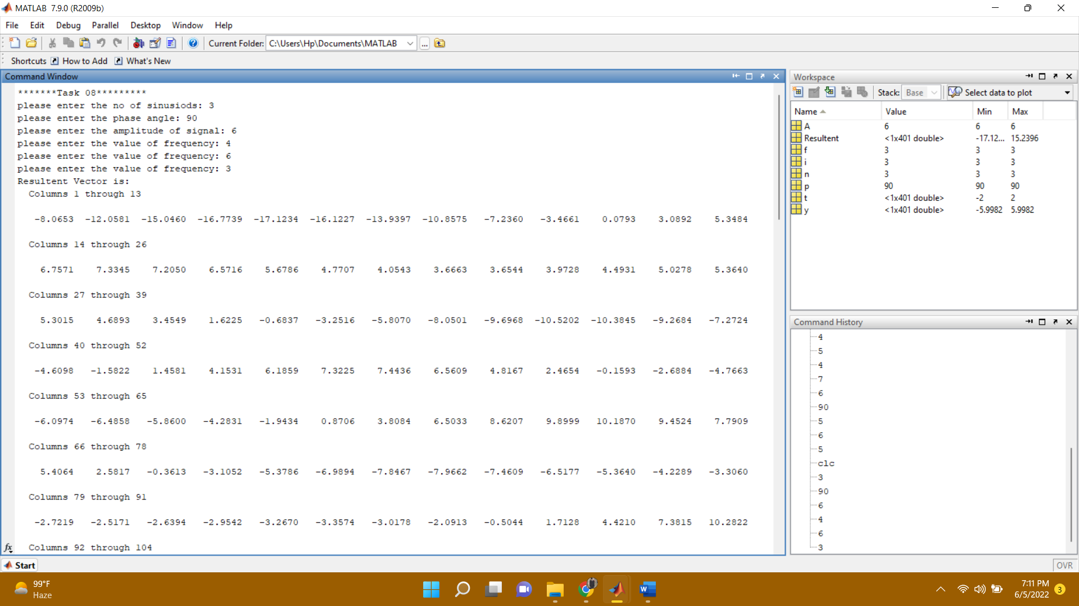

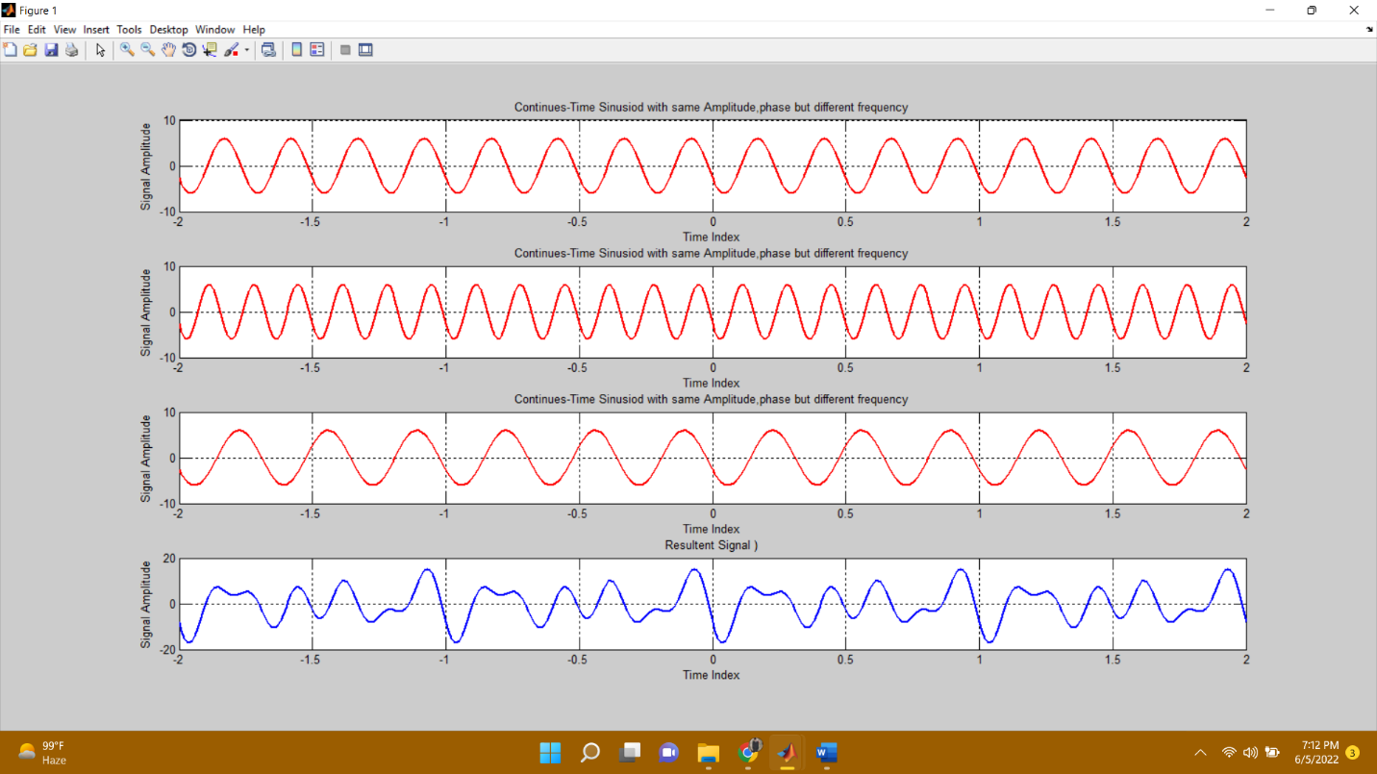

**Note:** As the frequency of individual signal 4 is more than other so the effect of that signal is more in resultant signal I,e resultant signal look like signal 4.

**-------------------------TASK 9--------------------------**

* Write a general program that takes ‘n’ sinusoids from user of same amplitude and frequency with varying phases. Take each phase from user on run time. Plot the individual sinusoids & the resultant using subplot function on same figure. Do perform proper labeling. Note: Take the amplitude and frequency given in example of case 4. Run the code for different values of n and state the result on paper.

**Source code:**

clc;

clear all;

close all;

disp('*******Task 09*********');

t=0:0.01:2;

n=input('please enter the no of sinusiods: ');

f=input('please enter the value of frequency: ');

A=input('please enter the amplitude of signal: ');

p = zeros(1,n);

Resultent=0;

for i=1:n % we can also create separate loop for varying parameter.

p(i)=input('please enter the phase angle: ');

end;

for i=1:n

y = A * cos(2*pi*f*t + p(i));

subplot(n+1,1,i)%in subplot we increase size of n for displaying Resultent plot.

plot(t,y,'r','linewidth', 2);

title('Continues-Time Sinusiod with same frequency,Amplitude but different phase');

xlabel('Time Index');

ylabel('Signal Amplitude');

Resultent=Resultent+y; %all vectors y are added element by element.

grid on;

end

disp('Resultent Vector is: ');

disp(Resultent);

subplot(n+1,1,n+1);

plot(t,Resultent,'b','Linewidth',2);

title('Resultent Signal )');

xlabel('Time Index');

ylabel('Signal Amplitude');

grid on;

**Output:**

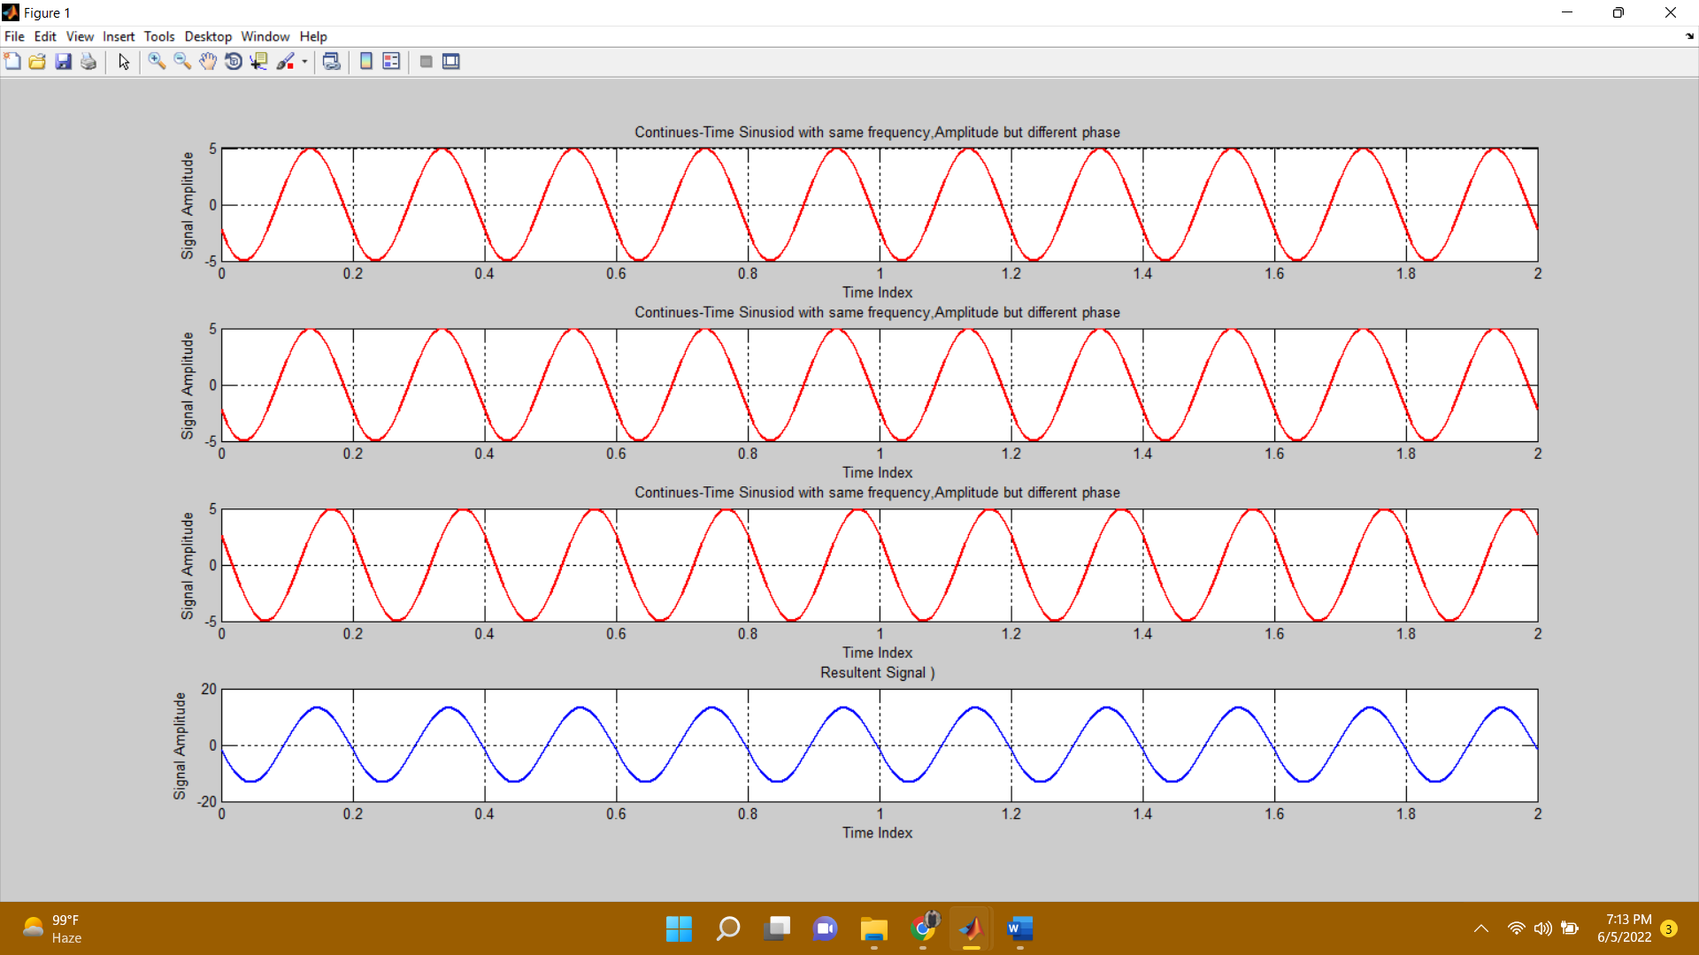

THE END